Fazaia Inter College

Winter Vacation Home Work

**Name: MUHAmmAD UMAR SAJJAD**

**ID: 16012**

**CLASS: 3rd - A**

**Subject: COMPUTER**

**TEACHER: Madam FAREENA**

**TOTAL MARKS: 10**

**Question.1:**

Send an email of 100 words to your friend telling him/her the difference between the two search engine i.e., Google Search and Yahoo Search. Mention which search engine is the best according to you? And which search engine do you prefer to use? Take a print of the email and paste it on the the A4 sized paper. (3.5 Marks = 2+0.5+1).

**Answer:**

The Email is attached below:

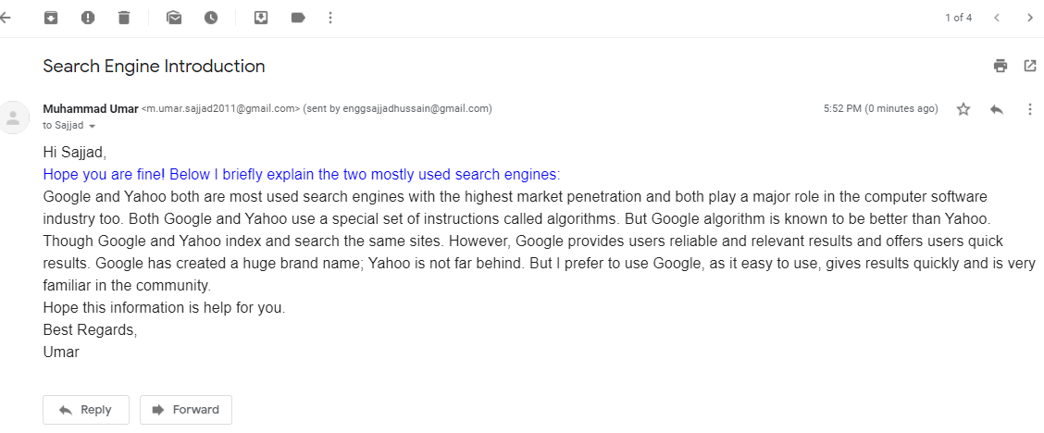

**Question.2:**

Take photos of at least 3 input or output devices you have at your home ad write interesting facts about the devices using MS word. Take a print of the document and submit it. **(3 Marks = 1+1+1)**

**Answer:**

The devices I use are as under:

|  |  |
| --- | --- |
| **Input/Output Device** | **Features** |
| Wireless Controller for PS4 (Input Device) | * Wireless, Bluetooth and USB Connection * Joystick Controller * Vibration Feeling * Chargeable * Touch Pad * Compatible with PS4 and PC |
| Dell 19 Flat Panel LED Monitor (Output Device) | * crystal-clear 1440 x 900 at 60Hz HD resolution * Tailor your settings to suit your applications with the Automate tab found in Dell Display Manager * Easily connect your desktop or laptop to the monitor via a standard VGA port, or DVI connector, |
| Dell Optical Mouse (Input Device) | * Connectivity Technology: Wired - USB * Color: Black * Weight: 3.07 oz * Movement Detection Technology: Optical * Movement Resolution: 1000 dpi |

**Question.3:**

Design a poster raising awareness of SOPs that need to be followed or the precautionary measures that need to be taken for COVID-19 using MS Word. You can be CREATIVE with it and take help from your parent. Take a print of the document and submit it. **(3.5 Marks)**

**Answer:** Attached below:

|  |
| --- |
| **COMMON STANDARD OPERATING PROCEDURES (SOPs)**  **To prevent COVID-19 spread** |